Problem Statement 1:

A company wants to analyze its sales data to identify trends and make informed decisions about its business. They have collected data from their sales transactions, including information such as customer demographics, product details, and transaction dates. The company wants to use this data to answer questions such as:

Which products are selling the most?

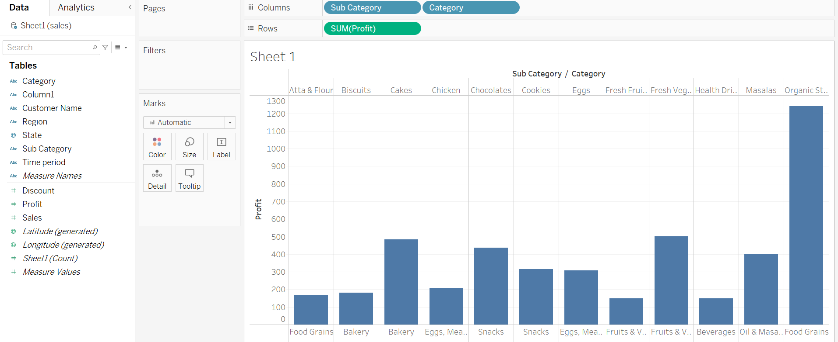

Which customers are making the most purchases?

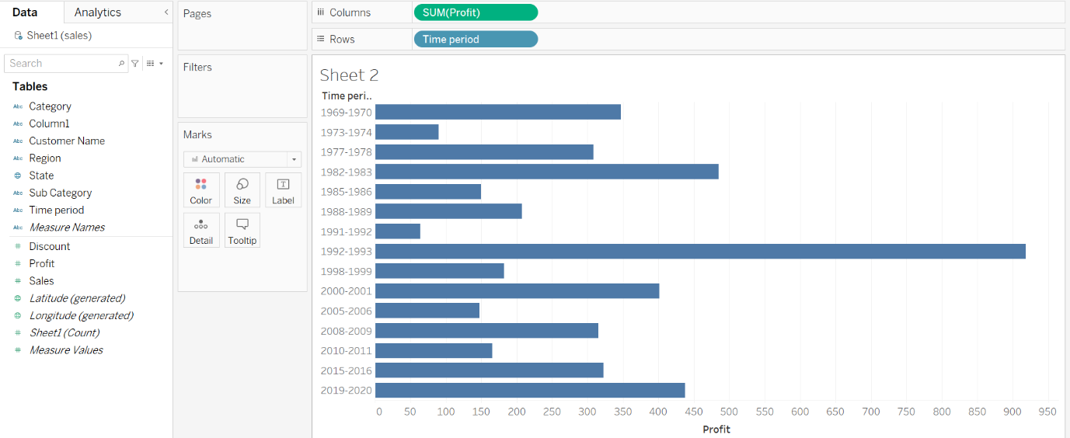

How do sales vary by region and time of year?

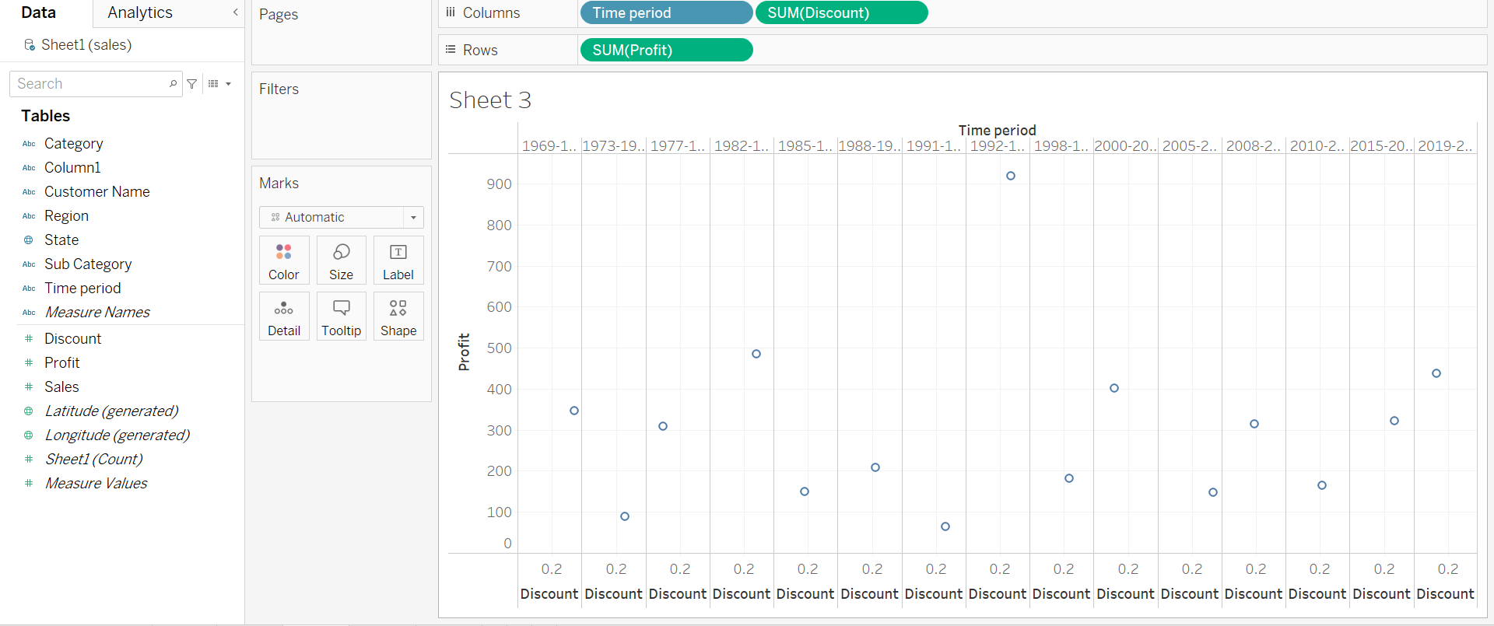

What factors are contributing to changes in sales over time?

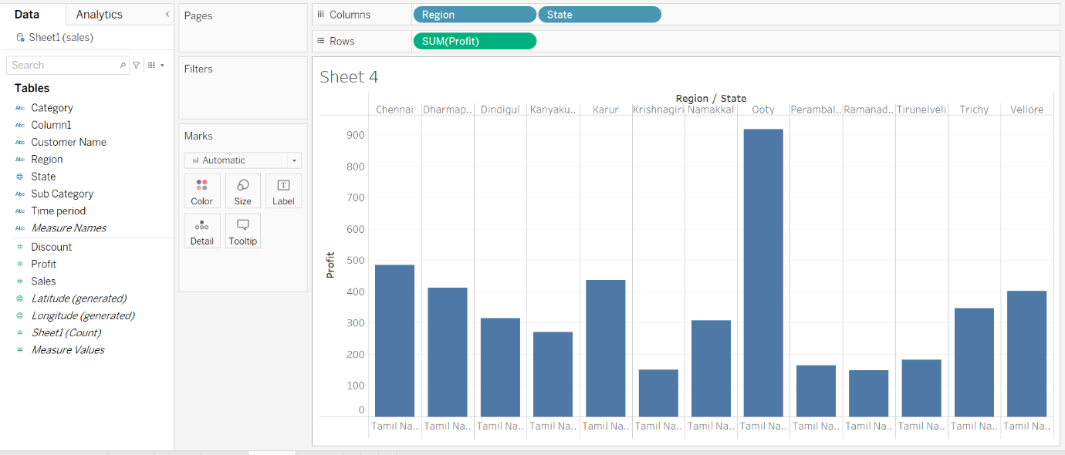

Problem Statement 2:

A healthcare provider wants to improve patient outcomes and reduce costs by identifying patients who are at high risk for readmission after being discharged from the hospital. The provider has collected data on patient demographics, medical history, and hospital stay details for a sample of patients, including whether or not they were readmitted within 30 days of discharge. The provider wants to use this data to develop a predictive model that can identify patients who are at high risk for readmission

